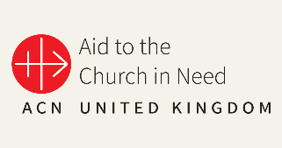Aid to the Church in Need

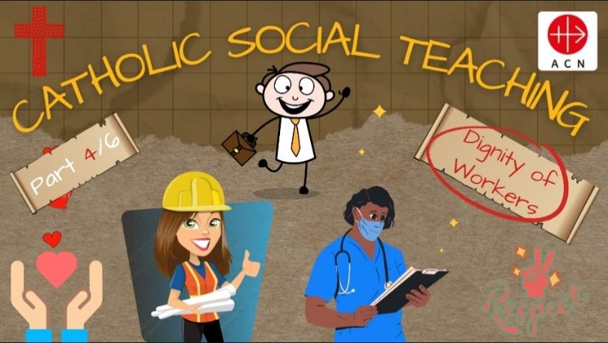‘Dignity of Workers’ Support Document  
  
‘T﻿here is no worse material poverty … than the poverty which prevents people from earning their bread and deprives them of the dignity of work.’

Pope Francis

This resource is the fourth in a series of six presentations (to be released on a half-termly basis) which has been created to support schools in developing pupils’ knowledge and understanding of Catholic Social Teaching (CST) as outlined in the revised RED, ‘To Know You More Clearly’. This presentation introduces/revises the various precepts of CST and subsequently focuses on the theme of ‘Dignity of Workers’. The presentation has been designed/structured so that the various components can be delivered as a whole, or different elements can be incorporated into different lessons/assemblies with a CST focus, particularly in the relation to the ‘Dignity of Workers’. The remaining presentations in the series will be as follows:

Summer 2: Human Dignity

Autumn 1: Care of Creation

Previous presentations (available in the Primary Resources section of the ACN UK website – see link below) are as follows:

Autumn 2: Preferential Option for the Poor

Spring 1: Solidarity and Peace

Spring 2: Community and Participation

A brief introduction to the history CST (including an excellent ‘CST in Three Minutes’ video from Trócaire ([https://www.trocaire.org/](https://www.trocaire.org/%20) ) is included in the first presentation (Preferential Option for the Poor: sides 8 – 30); this can be found in the Primary Resources section of the ACN website using the following link: <https://acnuk.org/resource/primary-acn-catholic-social-teaching/>

If your children have no prior knowledge of the origins of Catholic Social Teaching and its various precepts, this video provides an excellent introduction.

We hope that you and your pupils find this resource both engaging and informative as we continue to celebrate the Church’s ‘best kept secret’!

1. Aims

Through using these materials, pupils will:

* Explore the various precepts of Catholic Social Teaching (CST) in action through the work of ACN (Focus: Dignity of Workers).
* Understand how CST is embedded in scripture and explore how this is evident in both the Old and New Testaments.
* Reflect on how the world would be a better place if everyone chose to love their neighbour as themselves and actively live out the various principles of CST.
* Develop an understanding of the work of ACN to support poor and vulnerable Christian communities around the world (‘Dignity of Workers’ focus country: Syria).
* Reflect on societal exclusion (with a focus on the dignity of workers) and consider how they could follow in the footsteps of Jesus through supporting the work of ACN.
* Be able to describe how the work of ACN in the service of others is an example of following ‘The greatest commandment’.
* Engage with fundraising and/or prayer to support the work of ACN.

1. Catholic Self-Evaluation Document - Evidence

Through using this resource, school leaders will be able to provide evidence to support judgements in the following aspects of the Catholic Self-Evaluation Document (CSED):

Catholic Life and Mission (CLM)

CLM 1.3 Moral Development

CLM 1.4 Catholic Social Teaching

CLM 1.5 Respect for Self and Others

CLM 3.5 Commitment to Catholic Social Teaching

CLM 3.7 The Catholic Curriculum

Religious Education (RE)

RE1.1 Development of Knowledge, Understanding and Skills

RE 1.3 Religious Literacy

RE 2.6 Spiritual and Moral Development

RE 3.1 RED

RE 3.5 Curriculum Design

RE 3.7 Enrichment

Collective Worship (CW)

CW1.4 Influence of Curriculum and School Life

CW 1.5 Impact

CW 2.1 Centrality

CW 2.4 Use of scripture

CW3.5 Leaders’ Knowledge and Skill

1. ‘To Know You More Clearly’: The Religious Education Directory (RED)

The spiral structure of the curriculum enables a build-up, layering a critical dimension each year, deepening pupils’ understanding of the story of salvation, developing a common language, and exploring the ‘memory of the Church’ and her teachings and how these have formed part of the history of ideas in the development of humanity.

The spiral pathway students follow from their first steps into Catholic education means that teachers can plan for progression, moving through basic questioning and notional understandings to ever deeper levels of engagement with Christianity’s divine and human drama and its significance for humankind. (RED: ‘To Know You More Clearly’; 2023)

Whilst these materials do not aim to cover the full progression and understanding required by the RED in its spiral curriculum, they do aim to supplement and enhance this learning.

Knowledge Lenses – End of Phase Expected Outcomes

The RED identifies six knowledge lenses which detail what should be known by the end of each age-phase. This resource can support teachers in helping to evidence expected outcomes in the Hear, Believe, Celebrate and Live knowledge lenses.

Go to pp33 – 34 of ‘To Know You More Clearly’ for further commentary on Catholic Social Teaching within the revised RED.

Ways of Knowing

The RED identifies three ‘ways of knowing’ in its Programme of Study that enable skills to be developed at an appropriate level. The development of these aspects allows each knowledge lens to be explored appropriately. The ways of knowing are Understand (U), Discern (D) and Respond (R).

End of phase Age-Related Expectations, that could be linked to this resource are listed below.

* Age 5 - 7

R1.3.2. Reflecting on how Jesus is a ‘light’ for all people and consider how they can bring ‘light’ to their families and communities.

U1.6.2. Recognise that Catholics are a part of a global Christian family, and all Christians are sisters and brothers.

R1.6.1. Consider how Christians in their local parish community could work together to help people.

U1.4.2. Recognise that Jesus shows the importance of giving to others

U2.6.2. Describe an initiative Christians work on together locally and/or globally in the service of others.

D2.6.1. Consider an answer, with relevant reasons, to the question ‘Who is my neighbour?’

* Age 7 - 9

D3.1.2. Thinking about how all people should be treated equally.

R3.1.1. Making connections between experiences where people have not been treated equally and how this felt.

R.4.1.1. Considering how their own lives and the lives of their communities could be transformed by the virtues of faith, hope and love.

R.4.3.1. Reflecting on those that society excludes today and consider how they could show love for these people as Jesus did.

R.4.3.2. Considering how Jesus serves others and discuss how Christians can follow this example today. What could this mean for their lives and the lives of their local communities?

R.4.4.1. Reflecting on how the life and work of a person or organisation (historical or contemporary) lives out the works of mercy and/or the love for those oppressed by poverty and the inspiration they offer for their life.

R.4.5.3. Reflecting on how Christian communities continue the work of Jesus in the community where they live.

* Age 9 - 11

R5.1.3. Discussing what loving our neighbour means for Christians today, for example, welcoming asylum seekers and refugees. Express a point of view and give reasons relating to the Church’s teaching on the common good and love of neighbour.

R5.3.4. Reflecting on how the communities they are part of could be transformed if everyone chose to love their neighbour as themselves.

R5.5.2 Reflecting on how they can use their gifts to make a better world.

R6.1.1. Considering they ways in which their life and the life of their communities could be transformed by taking seriously the belief in the innate dignity and equality of all human beings.

R6.4.2. Considering how love of neighbour could transform their life and the lives of the communities they are part of, describing the actions they could take to begin this transformation.

R6.5.3. Reflecting on how the work of charities can support people facing injustice or persecution.

U6.5.6. Describe how one charity studied witnesses its Christian faith through its work.

U6.6.1. Explain in an age-appropriate way the meaning of ‘the common good’ and the principles of Catholic Social Teaching.

1. 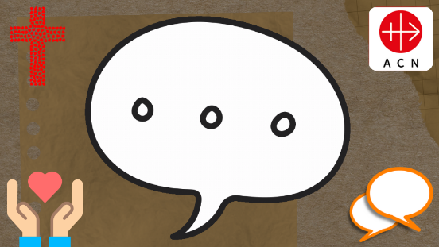Presentation Overview/Notes

This slide appears throughout the presentation and is intended to provide an opportunity for pupils to discuss their ideas/thinking related to the content. If required, you could duplicate this slide for use elsewhere in the presentation as appropriate.

|  |  |
| --- | --- |
| Slide 1 | If you have completed the first three presentations in the series (Preferential Option for the Poor; Solidarity and Peace; Community and Participation), explain that this is the fourth of a set of six (4/6) and that the focus for this ‘session’ is ‘Dignity of Workers’. If you have not used the ‘Preferential option for the Poor; resource, you could use slides 8 – 30 from this presentation to introduce the concept of Catholic Social Teaching (CST) to the children using this link. (<https://acnuk.org/resource/primary-acn-catholic-social-teaching/>) |
| Slide 2 | ‘‘Let all that you do be done in love.’ (1 Corinthians 16: 14)  Q: What is Paul saying to the people of Corinth? (People can make choices each day out of love that result in being patient, kind, and forgiving.)  Q: How might this quote from Corinthians relate to today’s theme?  Q: What have you already done ‘in love’ today? |
| Slides 3 - 5 | ‘‘There is no worse material poverty … than the poverty which prevents people from earning their bread and deprives them of the dignity of work.’ (Pope Francis)  Q: What does this quote from Pope Francis mean to you?  What do you understand by poverty/dignity? (see Glossary of Terms)  Poverty: The state of being extremely poor.  Dignity: Being worthy of honour or respect.  Q: What is the Pope telling us about the importance of work? |
| Slides 6 - 15 | A brief introduction/reminder of the various precepts (themes) of Catholic Social Teaching (CST) that will be explored in this series of presentations; the focus of this resource is ‘Dignity of Workers’. |
| Slides 16 - 18 | Q: What do you think that ‘Dignity of Workers’ means?  Allow children time to discuss this in pairs/groups; share ideas (slide 17).  Refer to the quote from Pope Francis on slide 3.  Q: how does this relate to the answers that you have just provided? |
| Slides 19 - 25 | In pairs/small groups/whole class: Challenge the children to come up with of five ways that workers should be shown respect in their roles. Children could use post-it notes/large sheets of paper to collate their ideas.  Q: Which of these ‘ideas’ do you think are most important?  Allow children to ‘rank’ their ideas and present them accordingly. |
| Slide 26 - 32 | Encourage the children to think about God as a ‘worker’ with reference to the Creation Story.  Q: What did God do on the seventh day?  Q: What does this tell us about the dignity of workers?  Slide 27 – 28: We are made in God’s image...so that means that we create too.  This could mean drawing a picture, writing a story, helping others or doing a job.  Slide 29: So, because we are made in the image of God...the dignity of everything that we do, in some way, reflects the work of God.  Q: How does this make you feel?  Q: What might you do differently now?  Allow children time to discuss/share their thoughts as appropriate. |
| Slides 33 - 35 | Parables: Discuss with/remind the children that Jesus used parables to help people understand all about the Kingdom of God and to challenge them.  Q: Can you think of any parables that you know?  Q: Can you explain their meaning?  Slide 35: If you feel it would be useful, show the Bible Project video about ‘Parables’.  Invite any thoughts and comments following the video. |
| Slides 36 - 42 | Introduce the parable of ‘The Workers in the Vineyard’ (Matthew 20: 1 – 16); explain that this was referenced in the video (2:12) as the parable of the business owner.  Slides 39 – 42: Share the parable of ‘The Workers in the Vineyard’ with the children; this could be simplified/paraphrased if using with younger children.  Reinforce the fact that all aspects of CST are embedded in scripture; CST helps us to understand how to ‘bring the Word to life’ in our daily lives. |
| Slides 43 - 54 | Slides 43 – 46: Having shared the passage from Matthew’s Gospel, ask the children the following questions; these could be asked/considered individually or collectively.  Q: Who was the landowner in this parable?  Q: How does this parable relate to the dignity of workers?  Q: Do you think that those workers who ‘complained’ were right to do so?  Possible additional activity: The third question could provoke an interesting ‘debate’; children could be split into threes/groups to represent the landowner, those workers who had worked all day and those who arrived later.  Slides 47 – 52: These slides provide an ‘explanation’ of the meaning of the parable – share and discuss, particularly:  Slide 51: No occupation should be considered superior; all jobs/professions should be seen as equally important.  Q: Do you think that this reflect society today?  Slide 52: No job is more important than another. Everyone should be able to be proud of the work that they do to earn a living.  Q: How does this relate to the activity that you completed earlier?  Slides 53 - 54: Provide children with the opportunity to review their ‘five ideas’ from earlier.  Q: Would any of your ideas make employees ‘feel proud’ of what they do’? |
| Slides 55 - 56 | If you have not used the previous CST presentations, or if the children have no prior knowledge of ‘Aid to the Church in Need’ (ACN), introduce the organisation to them; explain that ACN works on over 5000 projects in over 140 countries all around the world, helping to support the Church in its mission, and bringing hope and solidarity to millions of people. From priests to catechists and seminarians to Sisters, the donations received enable ACN to help persecuted and suffering Christians live out their faith (this will be explored further in subsequent slides.  Further information on the work of ACN can be found using the following link:  <https://acnuk.org/about/> |
| Slides 57 - 63 | These slides focus on some of the work/projects undertaken by ACN to support Christian communities in various regions of Syria; you could explain that many of the people in these communities have been persecuted for their beliefs and have often had to re-locate to a safer area/place so that they can continue to practice their faith and work/earn a living.  Share the examples of how ACN has supported various families through the ‘Hope Project’ (see video on slide 62) using the images/commentary on slides 59 – 64.  Allow children the time to reflect on the work of ACN in Syria; explain that these slides are examples of just a tiny fraction of the work undertaken by ACN and that all of the projects outlined are only made possible by charitable donations.  Q: How does the work of ACN in Syria through the ‘Hope Project’ link to the dignity of workers? (see below) |
| Slides 64 - 65 | Slide 64: This video outlines the impact of the Hope Project on John Sousani who received support from ACN to help him open an aluminium workshop.  WARNING: Please be aware that he first 60 seconds of the video does contain images of bomb-damaged areas and references the fact that the Sousani family have to live in a cemetery; if you would prefer not to share this with the children, you could commence playing from 1:01; alternatively, you could choose not to show the video and simply use the testimony on slide 65. |
| Slides 66 - 67 | Slide 57: Explain that ACN is a charitable organisation and that as such, they are dependent on contributions from individuals/organisations; through supporting the work of ACN, people are demonstrating their support/love for the communities included in the previous slides, and many more besides all around the world.  Q: Could your class/school support the work of ACN through organising a fundraising event (see slide 74)?  Slide 66: Reinforce the importance of remembering the people/communities that ACN supports in their prayers. |
| Slides 68- 74 | You Could Also…  These slides provide some possible ideas that you could use to help children further embed their understanding of the importance of promoting the dignity of workers through practical application. These are merely ideas and can be edited/deleted as appropriate.  Activity 1: Compile a ‘Workers’ Charter’ listing what employers should do to ensure that their staff are treated with dignity and feel valued in their roles.  Activity 2: Design a logo/symbol to promote the rights of workers.  (include a brief description of your logo/symbol).  Activity 3: Write an acrostic poem on the theme of ‘HOPE’; can you include reference to the work of ACN in Syria?  Activity 4: St. Joseph Fact File: St. Joseph is the patron saint of workers; what can you find out about him?  Activity 5: Organise a class/school fundraiser to support the work of ACN! |
| Slides 75 - 78 | These slides serve as a possible ‘plenary’ session, providing the children with the opportunity to reflect on their learning/understanding at an appropriate level.  Slides 75 – 76: A final thought from Pope Francis:  ‘I will never tire of referring to the dignity of work. What gives dignity is work. Those who do not have a job feel that they lack something, they lack the dignity that work gives them, that it anoints with dignity.’  Q: What does this tell you about the importance of the dignity of workers?  Q: What have you learnt from this session about the importance of the dignity of workers?  Q: What might you ‘do differently’ following this session?  Q: Do you have any questions/further thoughts that you’d like to share? |
| Slides 79 - 86 | Prayer and Reflection: children could be asked to read various prayers depending on their age; provide an opportunity for spontaneous prayer as appropriate. Previous scripture passages/quotes could also be incorporated into this collective worship session, along with an appropriate song; The Mark 10 Mission website contains a library of possible worship songs/hymns, including lyrics: <https://www.themark10mission.co.uk/worship-songs>  Remind children that their ongoing prayers for the people/communities supported by ACN are greatly appreciated/welcomed. |
| Slides 87 - 88 | The CST theme for Summer 2 is ‘Human Dignity’; this will be made available to schools before May half-term. |
| Slide 89 | Glossary of Terms – definitions of key terms/vocabulary used during the session; this is not an exhaustive list and you may need to explore other vocabulary at an age-appropriate level. See also the ‘Glossary of Terms’ from the first two sessions. |
| Slide 90 | Closing Slide. |

1. Fundraising for ACN

ACN is always grateful for the funds raised for its projects. Please note that the projects mentioned in this presentation are an example of its work. Your funding may go to these or similar projects.

Thank you for all that you do to support the work of ACN, both in your fundraising and in your prayers which are equally important.

Please let us know how you have raised funds via

* Twitter (X): @acn_uk
* Instagram: @aidtothechurchinneed_uk

(ACN – March 2024)